Your Child’s
Attendance Counts Today
Why Does Attendance Matter?

If children don’t show up for school regularly, they miss out on fundamental reading and math skills and the chance to build a habit of good attendance that will carry them into college and careers.

A California study found that children who were chronically absent in kindergarten and first grade were far less likely to read proficiently at the end of 3rd grade.

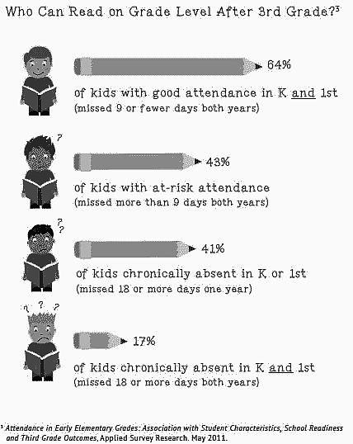

The law requires parents to report the reason for absence. Based on the excuse given, the school records the absence as excused or unexcused. However, in terms of learning, all types of absences are equal.

When Do Absences Become a Problem?

Based on a 180 day school year, the following definitions apply:

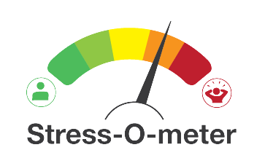
Number of Absences
At-Risk:
9-17
Chronic:
More than 18
Satisfactory: Less than 9
Attendance Meter

Did You Know?
- Starting in kindergarten, too many absences can cause children to fall behind in school
- Missing 10 percent (or 18 days) can make it harder to learn to read
- Students can still fall behind if they miss just a day or two every few weeks
- Being late to school may lead to poor attendance
- Absences can affect the whole classroom if the teacher has to slow down learning to help children catch up
- Students should miss no more than 9 days of school a year to stay on track to graduation
- Absences can be a sign that a student is losing interest in school, struggling with school work, dealing with a bully or some other serious situation
- By 6th grade, absenteeism is one of three signs that a student may drop out of high school
- By 9th grade, regular attendance is a better predictor of graduation rates than 8th grade test scores
- Students can be chronically absent if they only miss a day or two every few weeks
- Attendance is an important life skill that will help your child graduate from college and keep a job.

Good attendance will help children do well in high school, college, and at work.

What You Can Do
Elementary
- Set a regular bed time and morning routine
- Lay out clothes and pack backpacks the night before
- Introduce your child to her teachers and classmates before school starts to help her transition
- Don’t let your child stay home unless she is truly sick. Complaints of a stomach ache or headache can be a sign of anxiety and not a reason to stay home
- If your child seems anxious about going to school, talk to teachers, school counselors, or other parents for advice on how to make her feel comfortable and excited about learning
- Develop back-up plans for getting to school if something comes up. Call on a family member, a neighbor, or another parent.
- Avoid medical appointments and extended trips when school is in session.
Junior High and High School
- Talk about the importance of showing up to school every day, make that the expectation
- Help your child maintain daily routines, such as finishing homework and getting a good night’s sleep
- Try not to schedule dental and medical appointments during the day
- Don’t let your child stay home unless truly sick. Complaints of headaches or stomach aches may be signs of anxiety
- Find out if your child feels engaged by his classes and feels safe from threats. Make sure he’s not missing class because of behavioral issues or school discipline
- Stay on top of academic progress and seek help from teachers. Make sure teachers know how to contact you
- Stay on top of your child’s social contacts. Peer pressure can lead to skipping school, while students without many friends can feel isolated.
- Ask for help from school officials.

Responsibilities

Parents
As a parent you are responsible for making sure your child develops the habit of regular attendance.

School District
Per Education Code 48260.5, AUSD is required to notify parents of student absences. We notify parents according to the following schedule:
Notification of Unexcused Absences at 3, 5 and 7 absences.
Notification of Excused Absences at 5, 10, and 15 absences.
A student who misses more than 30 minutes of any given school day is considered absent.

Pre-SARB Conference
After five unexcused or ten excused absences, families are invited to an information meeting designed to ensure families are aware of current laws related to school attendance and the consequences for failing to meet school attendance requirements. The goal is to increase student attendance and connect the school to the family.

SARB Hearing
Student Attendance Review Board hearings are formal proceedings intended to provide solutions for students who have failed to respond to the normal avenues of school intervention.

EDUCATION CODE PENALTIES (PARENT)
The penalties against parents listed in Education Code §48293 is a fine or, in lieu of a fine, the court may order the person be placed in a parent education or counseling program.

PENAL CODE PENALTIES (PARENT)
Parents are subject to Penal Code § 270.1; a misdemeanor punishable by a fine not exceeding two thousand dollars ($2,000), or by imprisonment in a county jail not exceeding one year, or by both that fine and imprisonment.

EDUCATION CODE PENALTIES (STUDENT)
Penalties against students who are truant, pursuant to Education Code §48262, are as follows:
- Completing 20-40 hours of community service
- Paying a maximum fine of $50.00
- Suspension of or delay in issuance of a driver’s license, VC §13202.7

LOCAL RESOURCES

EMERGENCY NUMBERS
San Luis County 24-hour Hotline | 211
Police – Fire- Ambulance | 911
AUSD CONTACT INFORMATION
AUSD District Office | (805) 462-4200
Atascadero Fine Arts Academy | (805) 460-2500
Atascadero High School | (805) 468-4300
24-hour Attendance Line | (805) 462-4320
Atascadero Junior High School | (805) 462-4360
24-hour Attendance Line | (805) 462-4432
Carrisa Plains School | (805) 475-2244
Creston Elementary | (805) 238-4771
Del Rio Continuation | (805) 462-4350
Monterey Road Elementary | (805) 462-4270
San Benito Elementary | (805) 462-4330
San Gabriel Elementary | (805) 462-4360
Santa Margarita Elementary | (805) 438-5633
Santa Rosa Elementary | (805) 462-4290
West Mall (K-6) | (805) 438-5633
West Mall Alternative (7-12) | (805) 462-4393
COMMUNITY RESOURCES
AL-ANON | (805) 466-0959
Alcoholics Anonymous (AA) | (805) 466-0959
Child Care Resource Connection | (805) 544-4355
Community Health Center | (805) 792-1400
County Drug and Alcohol Services | (805) 461-6080
County Mental Health Service | (805) 461-6062
ECHO Homeless Shelter | (805) 462-3663
Healthy Families | (805) 466-5404
Hospice | (805) 544-2266
Loaves and Fishes | (805) 461-1504
Operation School Bell | (805) 462-4254
Parent Connection | (805) 543-3700
Parenting Help Line | (805) 904-1411
The Link Family Resource Center | (805) 466-5404

A.C.T.

ATTENDANCE COUNTS TODAY

OUR MISSION

To support the District’s Mission to empower students to be critical thinkers, lifelong learners, responsible citizens, and effective communicators by encouraging excellent attendance and reducing chronic truancy.

